Kicking TB: a real health score
One team: students, teachers and health professionals
One communication tool: the ball
One purpose: kicking TB
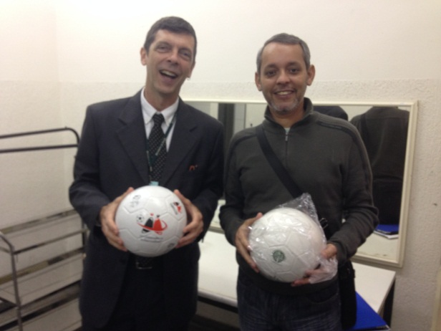
In the World Cup spirit, students from the Unified Educational Centre were introduced to the Project Kick TB Brazil on Tuesday, May 27th. The project’s purpose is to inform children about the disease using the national passion: football (for the Americans, soccer).
The project was firstly implemented by the South African Health Department for the 2010 World Cup event and it was adapted to the Brazilian reality trough a partnership with Stop TB Brazil, the Ministry of Health and Sao Paolo Health and Education Secretaries. The South African TB Programme shared their experiences and showed the way to successfully Kick TB in Brazil as well.
Associating the football spectacle to the need to social mobilization, the project intends to “Kick TB” through sharing information, raising TB awareness and involving children from strategic areas on the fight against TB. To that end, five thousand balls were produced with TB symptoms and prevention messages, and distributed to schools in strategic areas of Sao Paulo city, according to the methodology developed for the project.
Football teaches values such as tolerance, solidarity and team work, and Kick TB uses the sport as a communication tool for health messages in the schools.
The launching event
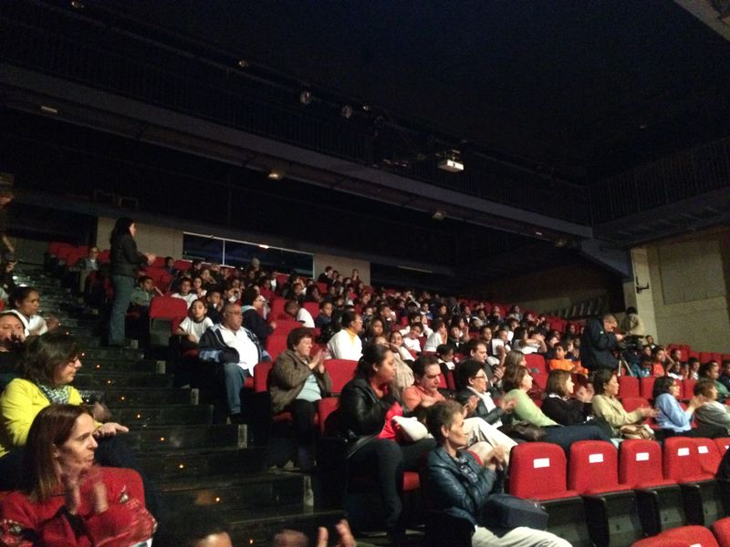
The event was opened by the Martial Band from Professor Eda Teresinha Municipal Middle School, which played many songs followed by choreography and rhythmic gymnastics from students. Before the solemnity with the authorities, a video was shown with a message from one of the most famous goalkeepers in Brazil – Rogerio Ceni, especially because he is the goalkeeper who scored more goals in the world. To see the video, access the link: http://www.youtube.com/watch?v=7UPtCYcH7Kk
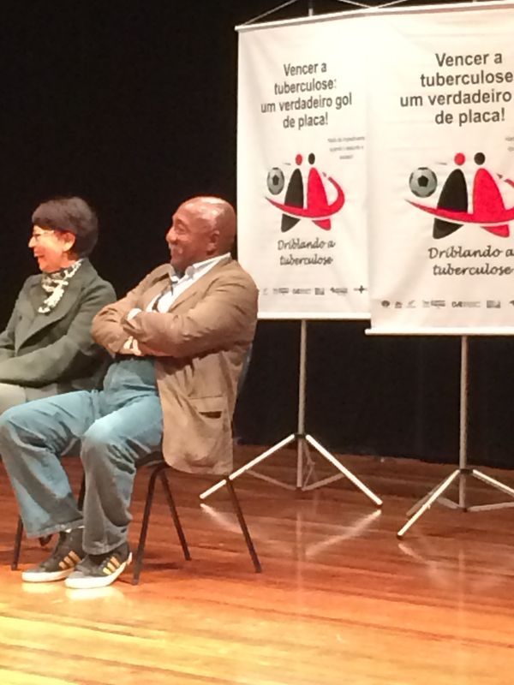
Many authorities from national and local levels attended the event: Stop TB Brazil Executive Secretary, Jair Brandao; Dr. Draurio Barreira, NTP Manager; Dr. Jose Aparecido, CEPHEID® Director in Brazil; Dr. Vera Galesi, Sao Paolo TB Programme Coordinator; Daniele Cruz, Health in School Programme Coordinator; the former football player three times world champion, Paulo Cezar Caju.
Very touched with the project’s concretization, activist and Stop TB Brazil executive secretary, Jair Brandao highlighted the importance of fighting the stigma and prejudice associated to TB, stressing the importance of family support to the success of treatment. “Isolation is a red card worthy action as it does not favor treatment completion. Giving all your love and support are green cards to fight TB”, he said.
The NTP manager, Draurio Barreira, believes that the project success is exactly the involvement of students as “health agents” disseminating the information learned and becoming actors in the fight against TB in a different perspective – as a channel to raise TB awareness in their homes, communities, among friends and school mates, and helping to detect new cases.
“In addition, the project was the great opportunity to strength the ties among health and education. Because TB is directly associated to social aspects we need to involve different actors on this fight” he stressed.
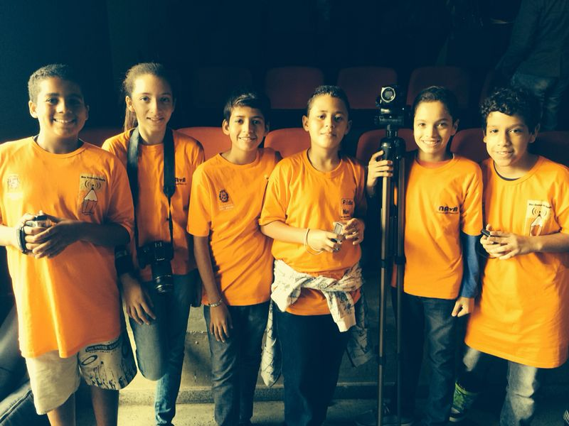
Excited with the project’s potential, the Sao Paulo TB Programme coordinator, Vera Galesi, signaled the State’s interest on expanding the project to other cities that are a priority in the TB control from the state of Sao Paulo, strengthening the partnership with the Health in School Programme.
To close the ceremony ”with a Golden Key”, the former football player Paulo Cesar Caju testified to the students how he kicked many difficulties he faced in life and became a World Cup champion and invited all students to kick TB in their communities.
During the event, ten children were selected to receive a ball from the authorities there present. The ceremony was all covered by the Kids’ TV – the media channel from the school composed by students only.
About the project
Five thousand balls were produced with TB symptoms and prevention messages, to be distributed and used for especial activities in different schools from strategic areas of Sao Paolo city. In addition, students, teachers and health professionals were sensitized to the different aspects of the disease such as symptoms, prevention, diagnosis and treatment, as well as social aspects like fighting stigma and prejudice, the importance to follow the treatment until completion and the support to TB patients.
The next step will be the delivery of the Health Passports to students. Through this tool, students will be able to analyze if TB symptoms are present in their families, acting as “health agents”, spreading their TB knowledge and identifying people who might have TB. After filling in the passport, it shall be returned to the teacher who will forward to health professionals. They will screen the symptomatic to the asymptomatic homes and schedule a visit for further orientation for those who are presented with TB signs.
A Monitoring and Evaluation plan is under development in order to measure the impact of the project, and based on the evidences, spread to the rest of the country.
Partnership with the Private Sector
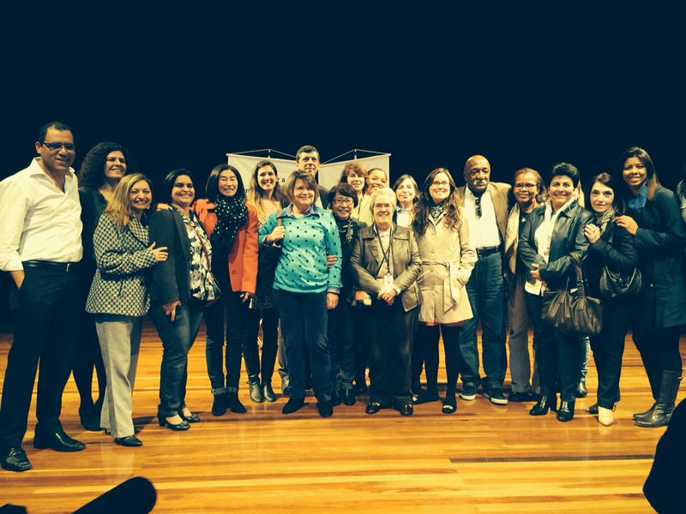
CEPHEID®, the company responsible for the development of the Molecular Rapid Test for TB diagnosis, Gene Xpert®, was the great supporter of the project. The company financed the production and delivery of the 5 thousand personalized balls with the disease information. The Brazilian representatives of the company followed the ceremony, where the government authorities recognized the importance of CEPHEID’s support. The Brazilian Director, Jose Aparecido, highlighted the company’s commitment to the fight against TB technically throughout their products, as well as socially, as Kick TB Brazil supporters.

